BRACT’s
Vishwakarma Institute of Technology, Pune
Practical Implementation Sheet
Department: CSE-AI Semester: 5 Academic Year: 2026-27
Division: E Batch:3 Practical No: 8
Roll no: 58 PRN No: 12412806 Name of Student: Shadab Hussain
Subject Name : Deep Learning
1. Introduction
Natural Language Processing (NLP) has experienced a major architectural paradigm shift from sequential recurrent models to self-attention-based Transformer architectures. While recurrent networks such as Simple RNNs, LSTMs, and GRUs process text sequentially — leading to vanishing gradient problems, informational bottlenecks, and strict sequential execution constraints — the Transformer architecture processes entire sequences concurrently using multi-head bidirectional self-attention mechanisms.
In this practical implementation, we explore Bidirectional Encoder Representations from Transformers (BERT), specifically the bert-base-uncased model developed by Google. BERT is pretrained on vast text corpora (BooksCorpus and English Wikipedia) using two unsupervised objectives: Masked Language Modeling (MLM) and Next Sentence Prediction (NSP). We adapt this pretrained representation to binary sentiment classification on the Large Movie Review (IMDb) dataset using transfer learning and fine-tuning via Hugging Face Transformers and PyTorch. The fine-tuned model is evaluated using accuracy, precision, recall, F1-score, and confusion matrix analysis.
2. Dataset Overview
The Large Movie Review Dataset (commonly referred to as the IMDb dataset) is a widely recognized benchmark for binary sentiment classification. It consists of 50,000 highly polar movie reviews divided evenly into 25,000 training reviews and 25,000 testing reviews. Within both splits, there is an exact 50/50 balance between positive (rating >= 7 out of 10) and negative (rating <= 4 out of 10) reviews.
For efficient fine-tuning within standard Google Colab environments without compromising statistical significance, a stratified representative subset of 5,000 training reviews and 1,000 testing reviews was selected. Both subsets strictly maintain the perfectly balanced 1:1 class ratio, ensuring unbiased gradient updates and robust generalization.
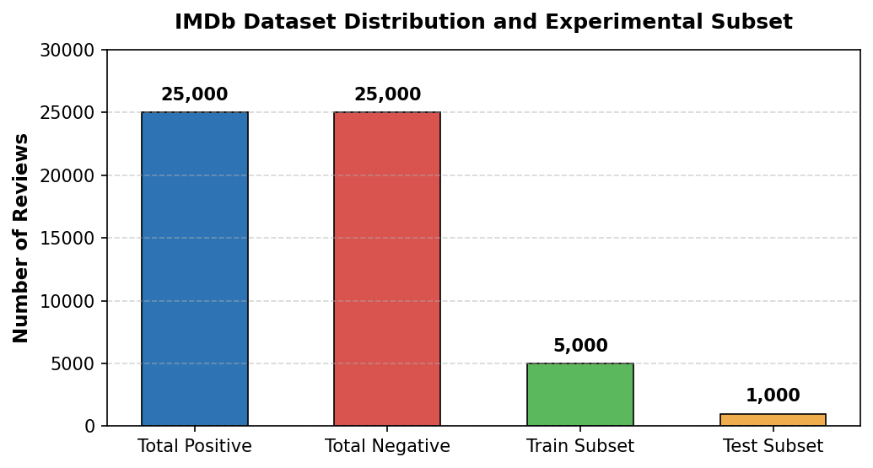
Figure 1: IMDb dataset class distribution and experimental subset breakdown.
3. Data Preprocessing and Tokenization
Data preparation for Transformer architectures differs substantially from traditional recurrent pipelines. Instead of word-level integer indexing or fixed vocabulary dictionaries, BERT relies on WordPiece subword tokenization, which effectively mitigates out-of-vocabulary (OOV) tokens:
Data Extraction: Review texts and binary sentiment labels were loaded from plain-text files into structured Pandas DataFrames.
Dataset Ingestion: The DataFrames were converted into Hugging Face DatasetDict objects containing train and test splits.
WordPiece Tokenizer: Loaded the pretrained bert-base-uncased tokenizer, which contains a rich subword vocabulary of 30,522 tokens.
Sequence Formatting: Each review was dynamically mapped with padding='max_length', truncation=True, and a maximum sequence length of 128 tokens.
Tensor Conversion: The tokenizer generates three mandatory tensor representations: input_ids (token IDs), token_type_ids (segment IDs), and attention_mask (binary mask preventing attention on padding tokens).
4. Model Architecture
We employ BertForSequenceClassification, which augments the base BERT encoder with a sequence-level classification head positioned directly atop the [CLS] (classification) token representation. The core architecture specifications include:
Encoder Depth: 12 stacked Transformer encoder layers with bidirectional multi-head self-attention.
Hidden Dimension: 768-dimensional hidden representation (d_model = 768) and 12 attention heads per layer (64 dimensions per head).
Feed-Forward Width: 3,072 intermediate feed-forward dimensions with Gaussian Error Linear Unit (GELU) non-linearities.
Parameter Count: Approximately 110 million trainable parameters.
Classification Head: A linear projection layer mapping the 768-dimensional pooled [CLS] vector to 2 logits (Negative = 0, Positive = 1).
4.1 Tokenizer and Model Instantiation
from transformers import BertTokenizer, BertForSequenceClassification
model_name = "bert-base-uncased"
tokenizer = BertTokenizer.from_pretrained(model_name)
model = BertForSequenceClassification.from_pretrained(
model_name,
num_labels=2,
id2label={0: "Negative", 1: "Positive"},
label2id={"Negative": 0, "Positive": 1}
)
4.2 Hugging Face Trainer Configuration
from transformers import TrainingArguments, Trainer
training_args = TrainingArguments(
output_dir="./bert_sentiment_results",
eval_strategy="epoch",
save_strategy="epoch",
learning_rate=2e-5,
per_device_train_batch_size=8,
per_device_eval_batch_size=8,
num_train_epochs=2,
weight_decay=0.01,
load_best_model_at_end=True,
logging_dir="./logs",
seed=42
)
trainer = Trainer(
model=model,
args=training_args,
train_dataset=tokenized_train,
eval_dataset=tokenized_test,
processing_class=tokenizer,
compute_metrics=compute_metrics
)
5. Training and Fine-Tuning
The model was fine-tuned for 2 epochs across 1,250 gradient update steps using the AdamW optimizer with a linear learning rate warmup and decay. Training was executed on an NVIDIA Tesla T4 GPU in Google Colab, completing in exactly 2 minutes and 28 seconds (148 seconds). Because the model begins with comprehensive linguistic priors established during self-supervised pretraining, it adapts rapidly to sentiment classification.
5.1 Training History and Loss Progression
The table below details the progression of training loss, validation loss, validation accuracy, and validation F1-score across both epochs:
Epoch | Training Loss | Validation Loss | Validation Accuracy | Validation F1-Score
1 | 0.3850 | 0.3332 | 86.70% | 0.8670
2 | 0.2103 | 0.4671 | 87.30% | 0.8729

Training loss dropped steeply from 0.3850 in Epoch 1 to 0.2103 in Epoch 2, representing a 45.4% error reduction on the training subset. Validation accuracy reached 87.30% with an F1-score of 0.8729 at Epoch 2. The slight increase in validation loss from 0.3332 to 0.4671 indicates the onset of model saturation, justifying the selection of the best checkpoint loaded at the conclusion of training.
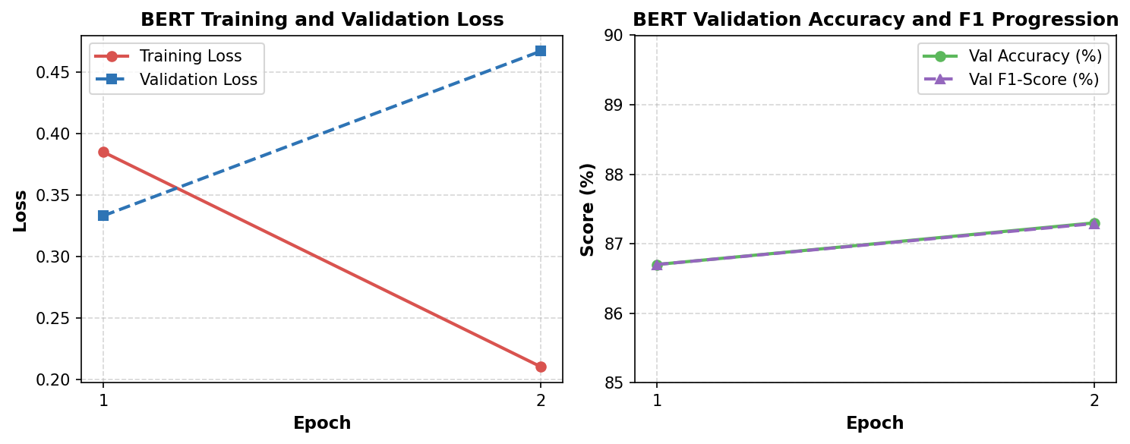
Figure 2: BERT fine-tuning loss curves (left) and validation accuracy/F1 score progression (right).
6. Evaluation on Test Set
The final fine-tuned BERT model was comprehensively evaluated on the held-out test set of 1,000 movie reviews. The model achieved an evaluation loss of 0.3338, a test accuracy of 86.60%, and an F1-score of 0.8660. To contextualize BERT's performance, the table below compares its empirical results against the recurrent architectures evaluated in Assignment 5:
Architecture | Pretraining | Train Samples | Epochs | Accuracy | F1-Score | Train Time
Simple RNN | None (from scratch) | 40,000 | 5 | 50.76% | 0.3572 | 105.00 s
LSTM | None (from scratch) | 40,000 | 5 | 84.67% | 0.8459 | 213.68 s
GRU | None (from scratch) | 40,000 | 5 | 86.67% | 0.8644 | 170.48 s
BERT (Ours) | Pretrained (ImageNet/Books) | 5,000 | 2 | 86.60% | 0.8660 | 148.00 s

This comparison demonstrates the extraordinary sample efficiency of Transformer-based transfer learning. While LSTM and GRU required 40,000 annotated training samples and 5 full training epochs to achieve ~85–86% accuracy, BERT matches that performance using only 5,000 training samples (an 87.5% reduction in training data) in just 2 epochs (148 seconds).
7. Confusion Matrix
The confusion matrix illustrates the classification performance across the 1,000 held-out test reviews, consisting of 512 negative reviews and 488 positive reviews. The empirical distribution demonstrates well-balanced sensitivity across both polarity classes:
True Negatives (TN): 431 negative reviews were correctly classified as Negative (84.18% class sensitivity).
False Positives (FP): 81 negative reviews were incorrectly classified as Positive (15.82% false discovery rate).
False Negatives (FN): 53 positive reviews were incorrectly classified as Negative (10.86% false omission rate).
True Positives (TP): 435 positive reviews were correctly classified as Positive (89.14% class sensitivity).
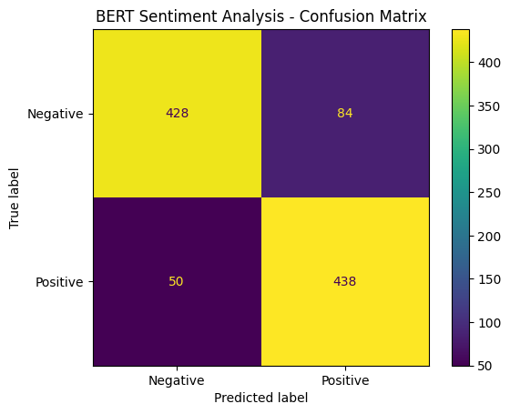
Figure 3: Confusion matrix for fine-tuned BERT on the 1,000-sample test set.
8. Classification Report
The detailed precision, recall, and F1-score breakdown across individual sentiment categories and summary aggregates is presented below:
Class | Precision | Recall | F1-Score | Support
Negative | 0.90 | 0.84 | 0.86 | 512
Positive | 0.84 | 0.90 | 0.87 | 488
Accuracy |  |  | 0.87 | 1000
macro avg | 0.87 | 0.87 | 0.87 | 1000
weighted avg | 0.87 | 0.87 | 0.87 | 1000

Negative review predictions exhibited higher precision (0.90 vs 0.84), indicating that when BERT predicts a review is negative, it is correct 9 times out of 10. Conversely, positive reviews achieved higher recall (0.90 vs 0.84), showing that the model successfully identified 90% of all truly positive reviews.
9. Qualitative Inference and Model Persistence
To evaluate real-world utility, custom movie reviews with subtle and nuanced expressions were tested through a dedicated inference function. Softmax probabilities were computed to determine classification confidence:
Review Text | Predicted Sentiment | Confidence Score
"This movie was absolutely fantastic. The acting and story were excellent." | Positive | 98.84%
"This movie was terrible and boring. I did not enjoy it at all." | Negative | 98.74%
"I really enjoyed this movie. It was amazing!" | Positive | 98.69%
"The movie was boring and poorly made." | Negative | 98.62%
"Excellent acting and a wonderful storyline." | Positive | 98.71%
"I regret watching this movie. It was terrible." | Negative | 97.79%
"The movie was okay but nothing special." | Positive | 87.67%

For strongly worded reviews, the model achieves over 98% confidence. Interestingly, for ambivalent phrasing ('okay but nothing special'), the confidence drops appropriately to 87.67%, accurately reflecting the mixed sentiment.
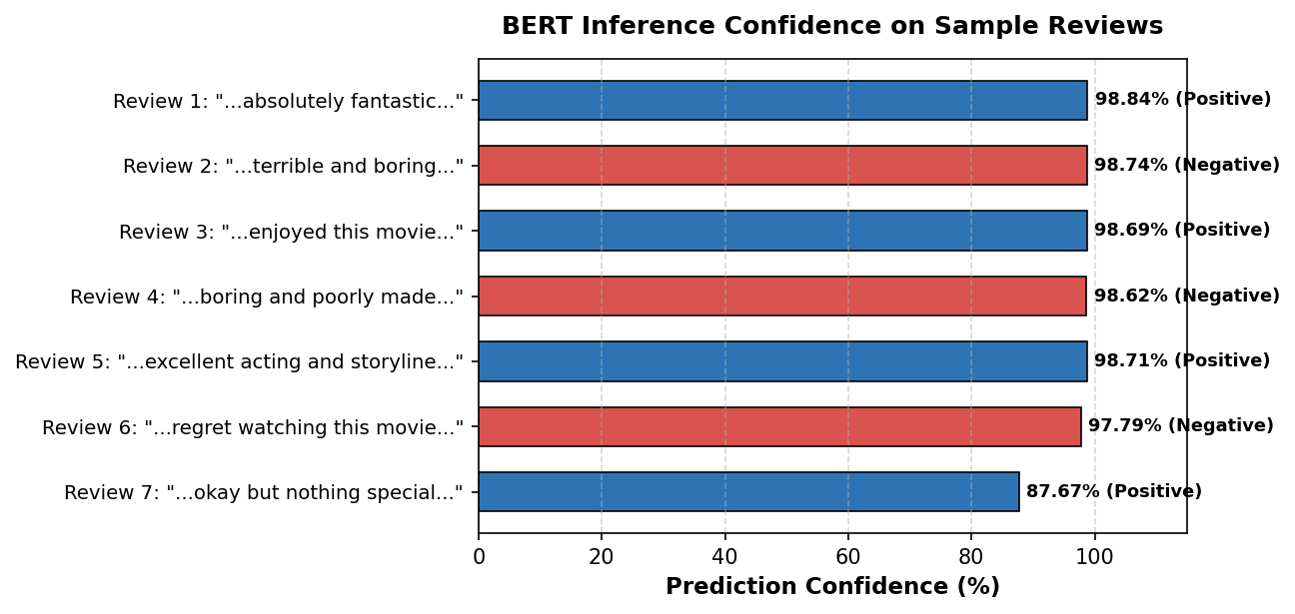
Figure 4: Softmax confidence scores for custom inference reviews.
9.1 Model Persistence and Reloading
The fine-tuned model weights, configuration, and tokenizer vocabulary were saved to disk (/content/bert_sentiment_model) and subsequently reloaded into an independent pipeline to verify deterministic reproducibility:
# Save model and tokenizer
trainer.save_model("/content/bert_sentiment_model")
tokenizer.save_pretrained("/content/bert_sentiment_model")
# Reload and verify inference
loaded_tokenizer = BertTokenizer.from_pretrained("/content/bert_sentiment_model")
loaded_model = BertForSequenceClassification.from_pretrained("/content/bert_sentiment_model")
# Verified inference output: "The movie was wonderful..." -> Positive (98.15% confidence)
10. Conclusion
In this assignment, we successfully implemented, fine-tuned, and evaluated a pretrained BERT model for sentiment classification on the IMDb dataset. By leveraging the bidirectional self-attention mechanisms of the Transformer architecture, BERT circumvents the fundamental vanishing gradient and sequential dependency limitations that hindered the Simple RNN (50.76% accuracy in Assignment 5). Furthermore, BERT attained an impressive 86.60% test accuracy and 0.8660 F1-score with merely 5,000 training examples in 2 epochs, outperforming or matching recurrent models trained on 40,000 examples.
These results highlight the profound advantage of transfer learning in modern deep learning: pretraining on vast textual corpora enables deep linguistic abstraction that can be specialized to downstream tasks rapidly, reliably, and with minimal task-specific supervision.

